# **Abstract -** The overall percentage of child basement filed nowadays in the world is about 80%, out of which 74% are girl children and the rest are boys. For every 40 seconds, a child goes missing in this world. Children are the backbone of one's nation, if the future of children was affected, it would impact the entire growth of that nation. Due to the abasements, the emotional and mental stability of the children gets affected which in turn ruins their career and future. These innocent children are not responsible for what happens to them. So, parents are responsible for taking care of their own children. But, due to economic condition and aims to focus on their child's future and career, parents are forced to crave for money. Hence, it becomes difficult to cling on to their children all the time. In our system, we provide an environment where this problem can be resolved in an efficient manner. It makes parents to easily monitor their children in real time just like staying beside them as well as focusing on their own career without any manual intervention.

## 1. INTRODUCTION

Basically, children cannot complain about abasements which they face in their daily life to their parents. They can’t even realize what actually happens to them at their age. It is also difficult for parents to identify their children are being abused. Since to prevent children before being attacked, an autonomous real-time monitoring system is necessary for every child out there. In this system, the collected values from every sensor like temperature sensor, pulse rate detection sensor, metal detection sensor, and the location value from GPS are used to detect the status of the child and alerts the respective guardians using GSM accordingly.

## 2. LITERATURE SURVEY

### A. RFID-based System for School Children Transportation Safety Enhancement

This paper presents a system to monitor pick-up/drop-off of school children to enhance the safety of children during daily transportation from and to school. The system consists of two main units, a bus unit, and a school unit. The bus unit the system is used to detect when a child boards or leaves the bus. This information is communicated to the school unit that identifies which of the children did not board or leave the bus and issues an alert message accordingly. The system has a developed web-based database-driven application that facilities its management and provides useful information about the children to authorized personnel. A complete prototype of the proposed system was implemented and tested to validate the system functionality. The results show that the system is promising for daily transportation safety.

### B. Design and Development of an IOT based wearable device for the Safety and Security of women and girl children

The aim of this work is to develop a wearable device for the safety and protection of women and girls. This objective is achieved by the analysis of physiological signals in conjunction with body position. The physiological signals that are analysed are galvanic skin resistance and body temperature. Body position is determined by acquiring raw accelerometer data from a triple axis accelerometer.

Acquisition of raw data is then followed by activity recognition which is a process of employing a specialized machine learning algorithm. Real-time monitoring of data is achieved by wirelessly sending sensor data to an open-source Cloud Platform. Analysis of the data is done on MATLAB simultaneously. This device is programmed to continuously monitor the subject’s parameters and take action when any dangerous situation presents itself. It does so by detecting the change in the monitored signals, following which appropriate action is taken by means of sending notifications/alerts to designated individuals.

### C. Child Safety Wearable Device

Parents need not have a smart mobile. Set of keywords are used to gain information from the kit. LOCATION keyword is used to obtain the location of the child. UV keyword is used to obtain the temperature of the surroundings. BUZZ keyword is used to turn on the buzzer which is fixed in that device. SOS is used to send a signal to the device.

### D. Smart Intelligent System for Women and Child Security

A portable device which will have a pressure switch. As soon as an assailant is about to attack the person or when the person senses any insecurity from a stranger, he/she can then put pressure on the device by squeezing or compressing it. Instantly the pressure sensor senses this pressure and a conventional SMS, with the victim’s location will be sent to their parents/guardian cell phone numbers stored in the device while purchasing it, followed by a call. If the call is unanswered for a prolonged time, a call will be redirected to the police and the same message will be sent. Additionally, if the person crosses some area which is usually not accessed by the person, then a message with the real-time location is sent to the parent/guardian's phone via conventional SMS.

## 3. EXISTING SYSTEM

Real-Time Child Abuse and Reporting System

In the existing system, we use a voice recognition module in which the alert commands from the child are stored and kept for further reference. If the same child delivers the same command, it will compare with the alert command which was previously stored and sets an emergency level according to the alert command. The GSM has a SIM which is used to send an alert message or an alert call to the trusted peoples. GPS is used to track the live location and it is used when needed. The server will search the respective device ID from the database and search for respective contacts according to that device ID and helps in alerting the registered guardians.

The disadvantage of this project is,

1. The child could not produce the exact alert command during a panic condition.
2. The command produced may not match with the previously stored command.
3. This project requires manual intervention.

## 4. PROPOSED SYSTEM

In the existing system, manual intervention was required. But in the proposed system, we make every action autonomously.

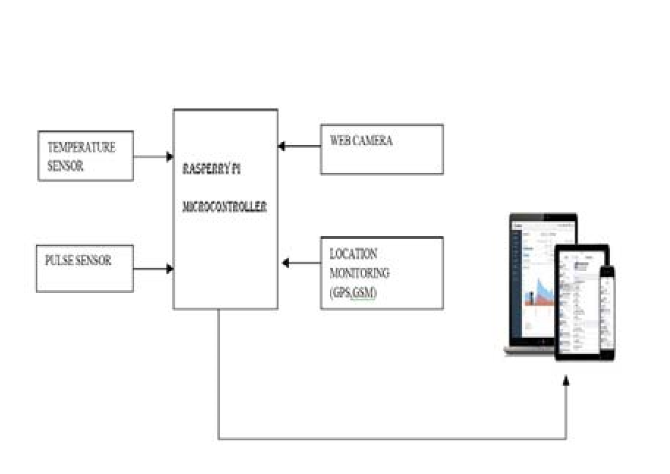

## Fig.1: Block diagram of the proposed system

We can use both web application as well as mobile application or either one of it as the front-end user interface, cloud, and database as the back end for storing and retrieving information, and a device for monitoring.

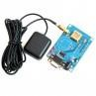

## Fig.2: GPS

GPS is used to track the live location of the child who is wearing that device. With the help of GPS, we can easily perform Geo-fencing concept, in which we will be able to feed a particular boundary to that device.

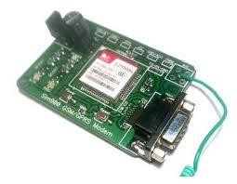

## Fig.3: GSM

If the child goes beyond that particular boundary specified, the respective guardians will receive an alert call using GSM.

In our system, we use several components like,

1.Temperature sensor

2.Pulse sensor

3.GPS

4.GSM

5.Web camera

6.Raspberry pi microprocessor

The Temperature sensor is used to sense the surrounding temperature of the device. If the temperature level exceeds the room temperature, then the alert message will be sent using GSM to the specified users.

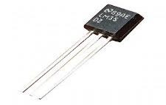

## Fig.4: TEMPERATURE SENSOR

The Pulse sensor is used to detect any abnormal feelings experienced by the child like fear, anxiety, nervousness, drowsiness and several other illnesses which manipulates the normal heart rate.

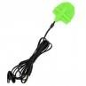

## Fig.6: PULSE SENSOR

These values are used to alert the specified guardians through SMS using GSM. When the user receives these alert messages from that device, they can turn on the web camera placed in that device, with which they can visually monitor the status of that child through the live video stream.

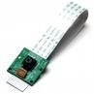

**Fig.7: WEB CAMERA**

## 5. WORKING

Our proposed system consists of Raspberry Pi microprocessor in which all other sensors, GPS and GSM are integrated. The users are required to register using their credentials to use the application. The device will be given to the children for monitoring them regularly. We will feed the boundary value while writing code for the system and we control it using GPS for that device which is also known as Geo Fencing. These data are stored in the server.

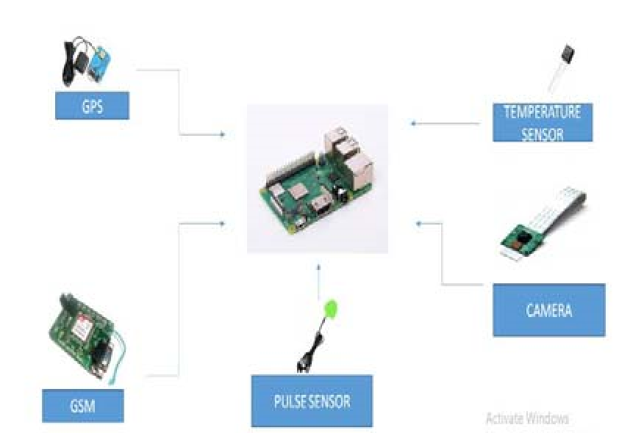

## Fig. 8: Architecture diagram of the proposed system

If the device moves, out of that boundary the server transfers an alert call by activating the GSM, to the user. The live location of the device will be updated in the server and pinged in the website for every few seconds. The server-side coding was written in PHP and the controller side coding was written in Python.

The user will receive an alert call and after entering the login ID and password, they can check the live location through GPS, which was updated in the application. When giving boundary for the school unit, we can also maintain attendance by updating the entry and exit of the child, in and out, of school in the application.

We feed specific threshold values for sensors like temperature and pulse in which, if the device exceeds those threshold values or if the device gets exposed to abnormal condition, then those values tend to be updated in the server. The server compares the currently obtained values with the coded threshold values, if they are beyond the threshold value, it generates an alert message through GSM. The alert messages are delivered to specified users in the form of SMS and the user can be able to login to the application to check the status and updated information.

After receiving the alert messages, if the user wants to visually check the status of the child, they are required to enter specific IP address of that camera for the first time before syncing and can be able to watch the live streaming videos which are updated to the server, for further uses they can directly view.

The microprocessor is used to control all these actions and the alert was done by checking for specific user of that device in the database.

## 6. RESULTS

One of the modules in our project is temperature sensor which is used to detect the temperature of the child as well as the surrounding temperature. If there occurs any abnormal rise or fall in temperature in the body of the child or in the surrounding it will notify the user as per the coded time delay as shown in the picture. It will show the temperature and humidity values notifies the user based on the predefined value abnormal fall or rise scenarios.

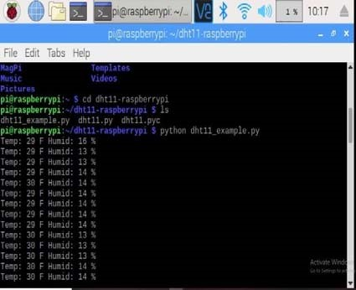

## Fig.9: Result 1

We also have a web camera through which we can monitor the child lively through live video streaming whenever we get notified in abnormal cases. We have an IP address for the camera fitted with the kit and we are supposed to enter that IP address in our mobile application or web application through which we can see the live video streaming of what's happening around the child as shown in the picture. we can monitor the child 24/7 in real time through the help of this live streaming which makes parents feel that they are beside their children ensuring children's safety.

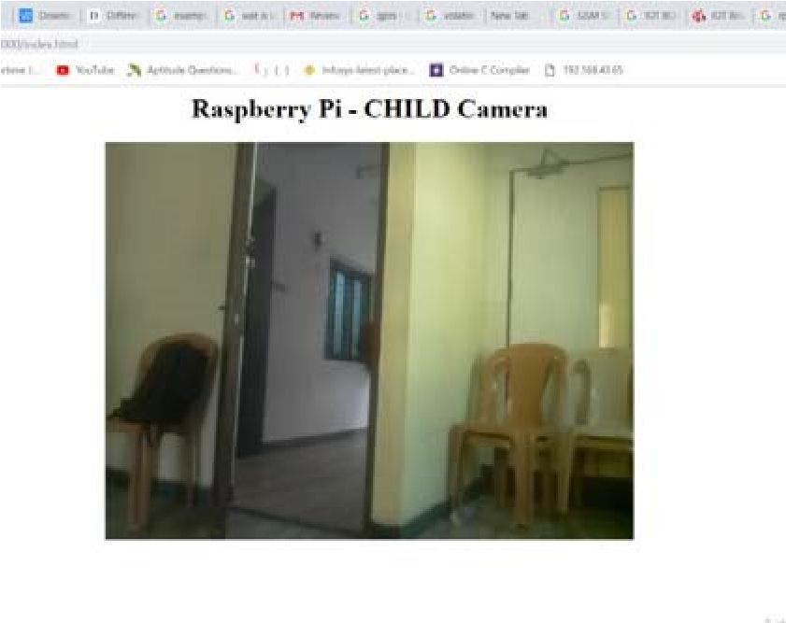

**Fig.10: Result 2**

## 7. FUTURE SCOPE

In our system, we automatically monitor the child in real time using Internet of Things, with the help of GPS, GSM, and Raspberry Pi. This system requires network connectivity, satellite communication, and high-speed data connection when we use web camera and GPS to lively monitor. It is difficult to monitor when there occurs any hindrance to satellite communication or any network issue. There also occurs time delay in video streaming through the server. Hence in the future, these issues can be overcome by using Zigbee concept or accessing the system without internet and using high-speed server transmission.

## 8. CONCLUSION

The word Future resembles the word Children. As DR. A.P.J Abdul Kalam’s words “Youngsters are the future pillars of one’s nation", today's children are tomorrow's youngsters, preserving their dreams and life for a better future is necessary. Therefore, each and every parent should take care of their own children, without letting them to fall into the dark world of abasements, which entirely ruin them physically, mentally and emotionally destroying our future. Hence, considering the importance of our future, our project makes it easy for parents to track their children and to visually monitor them on regular basis, which makes them ensure the safety of their children and reduces the rate of incidents of child abuse.

**TEAM ID: PNT2022TMID37952**

**TEAM BATCH NO: B7-1A3E**

**TEAM MENTOR: R. PADMAVATHY**

**TEAM LEADER: S. MADHUVANTHHI**

**TEAM MEMBERS:P. GLANY ROSE**

**V. POOJA**

**R. SANGEETHA**

**TEAM SIZE: 4**